Nisidh kumar

S24cseu1912

chmod 744 examQ.sh

./examQ.sh

Follow the menu options

text

Copy code

1) Add users from a file

2) Create project folders for a user

3) Save system information to a file

4) Manage user processes (list or kill)

5) Change permissions and owner/group of files or folders

6) Exit

Output 1

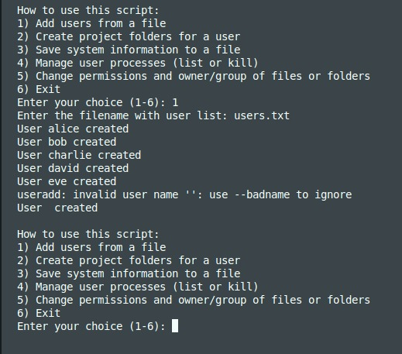

Output 2

Output 3

Out put 4

Output 5   
  
Output 6   
  
